|  |
| --- |
| FINAL YEAR PROJECT  JAVASCRIPT LEARNING WEBSITE |
|  |
|  |
|  |
|  |
|  |
|  |
| ADAM BIN MOHD YUSOFF |
|  |
|  |
|  |
|  |
|  |
| Bachelor Degree |
| UNIVERSITI MALAYSIA PAHANG |

UNIVERSITI MALAYSIA PAHANG

**DECLARATION OF THESIS AND COPYRIGHT**

Author’s Full Name : Adam bin Mohd Yusoff

Date of Birth : 27/05/2000

Title : JavaScript Learning Website

Academic Session :

I declare that this thesis is classified as:

|  |  |
| --- | --- |
| * CONFIDENTIAL | (Contains confidential information under the Official Secret Act 1997)* |
| * RESTRICTED | (Contains restricted information as specified by the organization where research was done)* |
| * OPEN ACCESS | I agree that my thesis to be published as online open access (Full Text) |

I acknowledge that Universiti Malaysia Pahang reserves the following rights:

1. The Thesis is the Property of Universiti Malaysia Pahang

2. The Library of Universiti Malaysia Pahang has the right to make copies of the thesis for the purpose of research only.

3. The Library has the right to make copies of the thesis for academic exchange.

Certified by:

|  |  |
| --- | --- |
| _____________________  (Student’s Signature)  _____________________  New IC/Passport Number  Date: | _______________________  (Supervisor’s Signature)  _______________________  Name of Supervisor Date: |
|  |  |

SUPERVISOR’s DECLARATION

I/We* hereby declare that I/We* have checked this thesis/project* and in my/our* opinion, this thesis/project* is adequate in terms of scope and quality for the award of the degree of in …………………………..

_______________________________  
 (Supervisor’s Signature)

Full Name :   
Position :   
Date :

_______________________________  
 (Co-supervisor’s Signature)

Full Name :   
Position :   
Date :

STUDENT’S DECLARATION

I hereby declare that the work in this thesis is based on my original work except for quotations and citations which have been duly acknowledged. I also declare that it has not been previously or concurrently submitted for any other degree at Universiti Malaysia Pahang or any other institutions.

_______________________________  
 (Student’s Signature)

Full Name : AHMAD MUSTAQIM BIN MOHD ZULI

ID Number : 201344899

Date : 12 October 2016

|  |
| --- |
| JavaScript Learning Website |
|  |
|  |
|  |
|  |
| ADAM BIN MOHD YUSOFF |
|  |
|  |
| Thesis submitted in fulfillment of the requirements  for the award of the degree of  Doctor of Philosophy/Master of Science/Master of Engineering |
|  |
|  |
|  |
|  |
| Faculty of Electrical & Electronics Engineering |
| UNIVERSITI MALAYSIA PAHANG |
|  |
| JUNE 2023 |

ACKNOWLEDGEMENTS

On the *Insert* tab, the galleries include items that are designed to coordinate with the overall look of your document. You can use these galleries to insert tables, headers, footers, lists, cover pages, and other document building blocks. When you create pictures, charts, or diagrams, they also coordinate with the current look of your document.

You can easily change the formatting of a selected text in the document text by choosing a look for the selected text from the *Quick Styles* gallery on the *Home* tab. You can also format the text directly by using the other controls on the *Home* tab. Most controls offer the option of either using the look from the current theme or using a format that you specify directly.

To change the overall look of your document, choose new theme elements on the *Page Layout* tab. To change the looks available in the *Quick Styles* gallery, use the *Change Current Quick Style Set* command. Both the Themes gallery and the *Quick Styles* gallery have reset commands so that you can always restore the look of your document to the original one in your current template.

**Table of Content**

**CHAPTER** **1** 9

**INTRODUCTION** 9

**1.1** **Introduction** 9

**1.2** **Problem Statement** 9

**1.3**  **Objective** 10

**1.4**  **Scope** 11

**CHAPTER 2** 14

**LITERATURE REVIEW** 14

**2.1**  **Introduction** 14

**2.2** **Existing Work** 14

**2.2.1** **CodeAcadamy** 14

**2.2.2** **FreeCodeCamp** 18

**2.2.3** **Code Combat** 19

**CHAPTER 3** 22

**METHODOLOGY** 22

**3.1** **Introduction** 22

**3.2.1** **Requirement phase** 23

**3.2.2** **Design Phase** 24

**3.2.3** **Development Phase** 25

**3.2.4** **Testing Phase** 26

**3.2.5** **Deploy Phase** 26

**3.3**  **Project requirements** 27

**3.4**  **Proposed Design** 28

**3.5** **Data Design** 30

**3.5.1**  **Context Diagram** 30

**3.5.2** **User Case Diagram & Descriptions** 30

**3.5.3** **Activity Diagram** 36

**3.5.4**  **Entity-Relationship Diagram (ERD)** 37

**3.5.5** **Database Dictionary** 38

**3.6** **Proof of Initial Concept** 40

**3.7** **Testing/Validation Plan** 42

**3.7.1** **Functionality Acceptance Test** 42

**3.7.2** **User Acceptance Test** 42

**3.8** **Potential Use of Proposed Solution** 42

**3.9** **Gantt Chart** 44

**CHAPTER 4** 45

**4.1** **Overview** 45

**4.2** **Implementation** 45

**4.3** **Result** 48

# **CHAPTER** **1**

**INTRODUCTION**

## **Introduction**

In today's fast-paced digital age, where technology plays a pivotal role in shaping various industries, the ability to code has become increasingly essential. Proficiency in coding not only opens up a vast array of job opportunities but also equips individuals with valuable problem-solving skills that are highly sought after in the modern workforce. However, Malaysian students encounter numerous challenges when it comes to learning how to code, particularly in the realm of JavaScript, which stands as one of the most widely used programming languages for web development.

The significance of JavaScript proficiency cannot be overstated, as it serves as the backbone for interactive web applications, dynamic content manipulation, and responsive user interfaces. Despite its importance, many Malaysian students struggle to grasp the intricacies of JavaScript, hindered by limited access to quality learning resources, insufficient guidance, and a lack of engaging learning platforms tailored to their specific needs.

To address this pressing issue and bridge the gap in coding education, this thesis aims to embark on a transformative journey to develop a comprehensive website explicitly designed to cater to the unique requirements of Malaysian students. The primary objective is to provide an accessible and engaging platform that facilitates the acquisition of JavaScript programming skills, empowering students at various proficiency levels to embark on their coding odyssey.

## **Problem Statement**

In the context of the growing demand for coding skills, Malaysian students encounter various barriers when it comes to learning JavaScript. These challenges can be summarized as follows. Firstly, there is a lack of access to high-quality learning resources, as many students either do not have access to such resources or are unable to afford coding classes or bootcamps. Secondly, students may possess theoretical knowledge of coding concepts but struggle to apply them practically due to limited exposure to coding tools and platforms. Thirdly, language barriers pose a significant hurdle, as coding resources are predominantly available in English, making it difficult for non-English speakers to learn coding effectively. Lastly, a lack of motivation may hinder students' progress, as learning to code requires dedication and perseverance.

To address these issues, this project proposes the development of a comprehensive website that offers an array of interactive and engaging learning resources. The website will provide coding challenges, video tutorials, quizzes, and other educational materials specifically tailored to learning JavaScript. By offering an accessible and user-friendly platform, this website aims to bridge the gap in coding education and empower Malaysian students to acquire the necessary skills to thrive in the digital economy. Through the utilization of interactive elements, practical exercises, and personalized learning paths, the website will foster a supportive and motivating environment that encourages continuous learning and growth.

By addressing the lack of access to quality resources, facilitating practical coding experiences, accommodating diverse language needs, and fostering motivation, this website intends to overcome the existing barriers and enable Malaysian students to embark on a successful coding journey. Ultimately, the goal is to equip students with the essential coding skills required to seize a wide range of job opportunities and contribute effectively in the ever-evolving digital landscape.

## **1.3 Objective**

The objective of this project is to develop a website to help Malaysian students learn coding JavaScript. The specific objectives of the project are as follows:

* To develop a user-friendly and interactive platform that provides students with access to a range of coding resources, including video tutorials, coding challenges, and quizzes.
* To study the website in a way that caters to the needs of both beginners and more advanced learners, with content that is structured to build knowledge progressively.
* To evaluate the effectiveness of the website in terms of student engagement, learning outcomes, and user satisfaction.

## **1.4 Scope**

The scope of this project includes the development of a website that provides Malaysian students with a platform to learn coding JavaScript. The website will include the following features:

1. Video tutorials: A library of video tutorials that cover fundamental concepts in JavaScript programming, as well as more advanced topics.
2. Coding challenges: A series of coding challenges that allow students to practice their coding skills and test their knowledge.
3. Quizzes: A range of quizzes that assess students' understanding of key coding concepts.
4. Interactive coding environment: A coding environment where students can apply their knowledge in practice, with access to tools and resources that support their learning.
5. Community forum: A community forum where students can ask questions, share knowledge, and connect with other learners.
6. Progress tracking: A feature that allows students to track their progress and set learning goals.

The scope of this project is limited to the development of the website and does not include any offline resources or physical events. The target users of the website are Malaysian students who are interested in learning how to code JavaScript, regardless of their level of experience.

5 Significance of Project The proposed website has significant importance in several ways. Firstly, it addresses the issue of limited access to quality learning resources, providing an accessible and engaging platform for Malaysian students to learn JavaScript programming. Secondly, it helps to bridge the gap in coding education, particularly for non-English speakers, by offering resources in both English and Bahasa Malaysia. Thirdly, the website aims to motivate students to learn coding by providing a range of interactive and engaging resources, helping to overcome the barrier of lack of motivation. Finally, by evaluating the effectiveness of the website, the project aims to contribute to the development of best practices in online coding education, with potential benefits for the wider educational community.

This thesis consists of five chapters. Chapter one discusses the introduction to the project, which includes the background of the study, problem statement, research questions, objectives, scope, and limitations.

The background of the study highlights the importance of learning to code in today's digital age and the challenges Malaysian students face in learning JavaScript. These challenges include lack of access to quality learning resources, limited exposure to practical coding experience, language barriers, and lack of motivation.

The problem statement identifies these challenges and proposes a solution in the form of a website that offers interactive and engaging resources to help Malaysian students learn JavaScript. The website is designed to cater to the needs of beginners as well as more advanced learners, with content structured to build knowledge progressively.

The research questions and objectives of the project are also discussed in Chapter one. The research questions focus on the effectiveness of the website in terms of student engagement, learning outcomes, and user satisfaction. The objectives of the project are developed using the SMART framework, ensuring that they are specific, measurable, achievable, realistic, and anchored within a time frame.

The scope and limitations of the project are also outlined in Chapter one. The scope includes the development of a website that provides Malaysian students with a platform to learn coding JavaScript, with features such as video tutorials, coding challenges, quizzes, an interactive coding environment, a community forum, and progress tracking. The limitations of the project include the exclusion of any offline resources or physical events. The target users of the website are Malaysian students who are interested in learning how to code JavaScript, regardless of their level of experience.

Finally, Chapter one discusses the significance of the project. The proposed website addresses the issue of limited access to quality learning resources, helps to bridge the gap in coding education, particularly for non-English speakers, and aims to motivate students to learn coding by providing a range of interactive and engaging resources. The project also aims to contribute to the development of best practices in online coding education, with potential benefits for the wider educational community.

In summary, Chapter one provides an overview of the project, highlighting the context, problem statement, research questions, objectives, scope, limitations, and significance of the proposed website.

# **CHAPTER 2**

**LITERATURE REVIEW**

## **2.1 Introduction**

The field of web development is constantly evolving, and the demand for skilled web developers is on the rise. As such, there is a need for accessible and effective learning resources for individuals interested in learning web development skills, such as JavaScript. Online learning platforms have emerged as a popular way for people to learn new skills, including coding. In this chapter, we will review the existing systems for JavaScript learning websites and compare their features, advantages, and disadvantages. The aim of this literature review is to identify gaps in the existing systems and inform the development of a new JavaScript learning website that provides an optimal learning experience for its users.

## **2.2 Existing Work**

### **2.2.1 CodeAcadamy**

Codecademy is an online interactive platform that offers coding classes and courses in various programming languages, including Python, JavaScript, Ruby, SQL, and others as shown in Figure 2.1. The platform was launched in 2011 with the goal of making programming education more accessible and engaging for people of all ages and backgrounds.

Codecademy's JavaScript course is a comprehensive and effective introduction to the programming language. The course is well-structured and starts with an overview of JavaScript and its uses in web development. Each section builds on the concepts learned in previous sections, and the interactive exercises and projects were particularly helpful in reinforcing the concepts taught.

One of the strengths of Codecademy's course is its interactive coding environment. The immediate feedback provided on learners' code is very helpful for identifying and correcting errors. The exercises and projects are challenging but not overwhelming, and they provide an opportunity to practice coding skills in a real-world context.

While the course is generally effective, some of the more advanced concepts can be difficult to grasp. Closures and scope, for example, can be particularly challenging for beginners. However, with practice and revisiting the material, learners can master these concepts.

In addition to their comprehensive introduction to JavaScript, Codecademy offers a range of career-oriented classes and courses that allow users to focus on the topics that are most relevant to their career path. These courses are divided into multiple levels, from beginner to advanced, ensuring that learners can progress at their own pace and challenge themselves as they become more proficient.

By offering these focused courses, Codecademy helps learners to deepen their knowledge of JavaScript and prepare for real-world applications. Whether learners are interested in front-end development, back-end development, or full-stack development, there are courses and classes available that will meet their needs as shown in Figure 2.3.

Overall, Codecademy's JavaScript course is an excellent resource for anyone looking to learn the language. The course is well-structured, and the interactive exercises and projects provide a great opportunity to practice coding skills. The immediate feedback provided by the coding environment is also very helpful, and learners can track their progress and earn badges as they work through the course.

Codecademy also offers a range of features and tools to enhance the learning experience, including a coding environment, quizzes, forums, and a community of learners and instructors. The platform has been used by millions of learners around the world, from beginners to professionals, to learn new coding skills and advance their careers in technology.

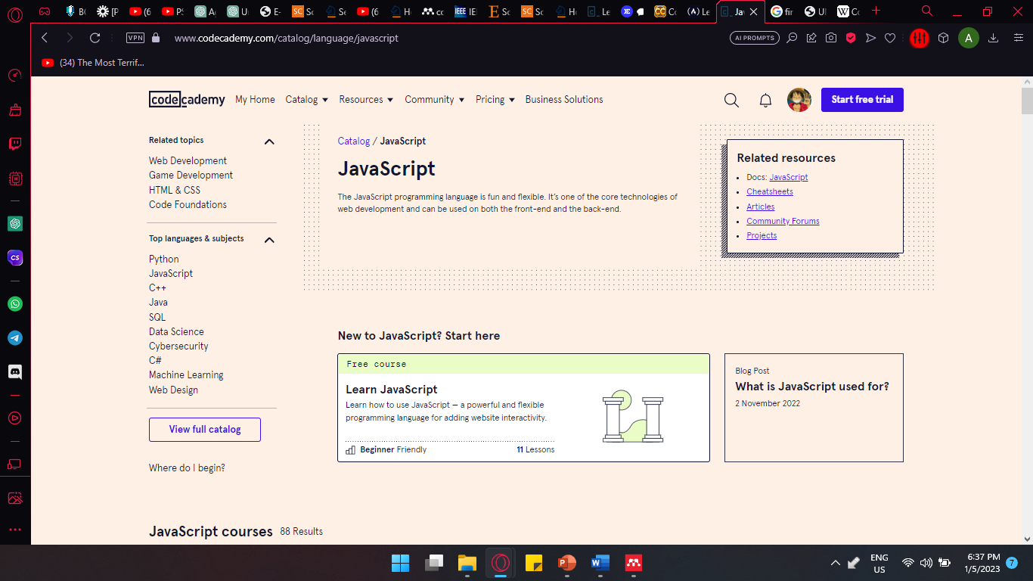

Figure 2. 1 Front page of CodeCademy’s JavaScript Course

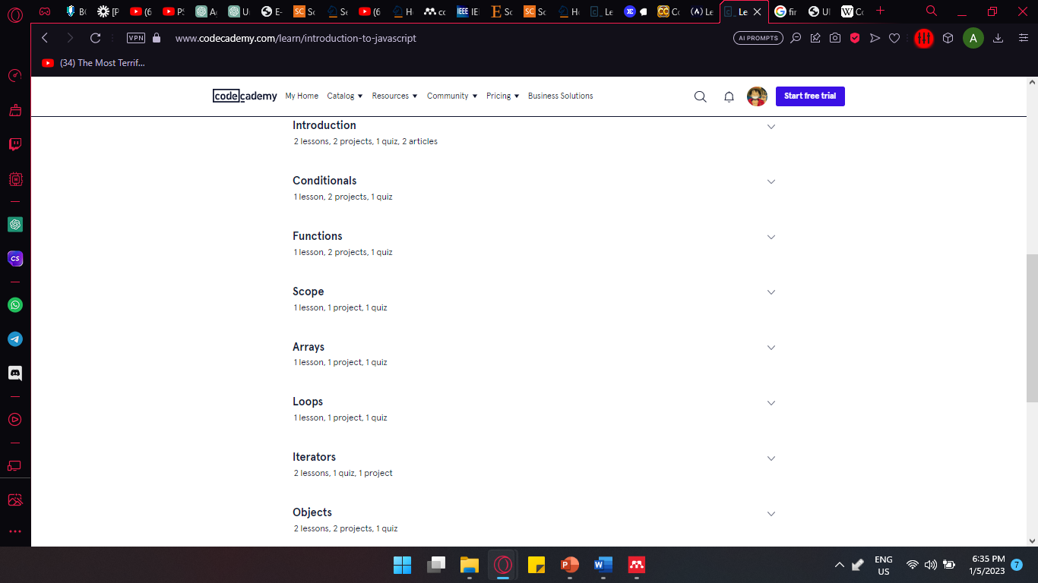

Figure 2. 2 contents of CodeCademy’s JavaScript Course

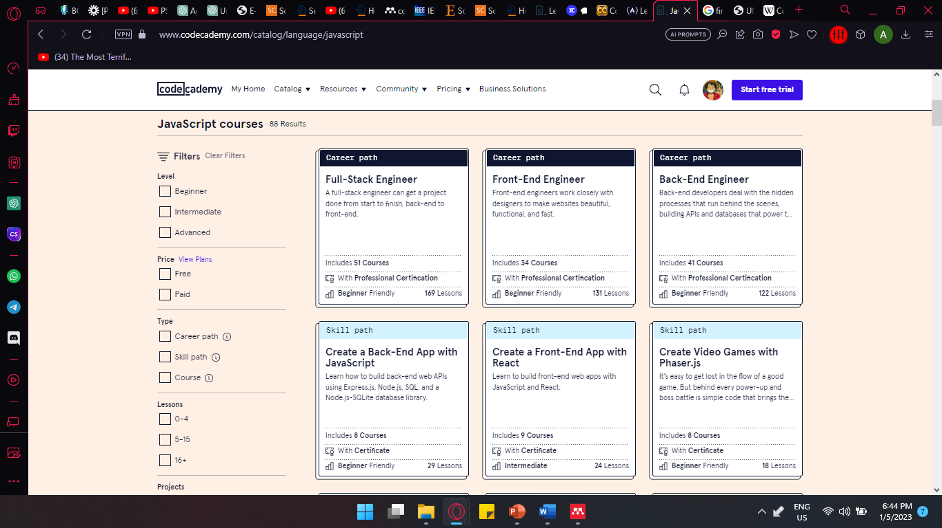

Figure 2. 3 CodeCademy’s large collection of Courses

Other than about the general of JavaScript, CodeAcadamy also provide a more advance career-oriented classes and courses thats related to JavaScript.

### **2.2.2 FreeCodeCamp**

FreeCodeCamp is a non-profit organization that provides free coding education to anyone, anywhere in the world. One of their most popular offerings is the JavaScript course, which aims to teach users the fundamentals of the programming language, as well as how to build web applications using JavaScript.

The FreeCodeCamp JavaScript course consists of a series of interactive challenges and projects that allow users to practice coding in a hands-on way. The course covers a wide range of topics, including variables, functions, arrays, loops, objects, and more as shown in Figure 2.4. It also includes more advanced topics such as functional programming, asynchronous programming, and using third-party APIs.

In addition to the coding challenges and projects, the FreeCodeCamp JavaScript course also includes comprehensive documentation and video tutorials, as well as a supportive community forum where users can ask questions and collaborate with other learners.

Overall, the FreeCodeCamp JavaScript course provides a comprehensive and accessible way for users to learn and master one of the most widely used programming languages in the world, making it an excellent resource for beginners and experienced coders alike.

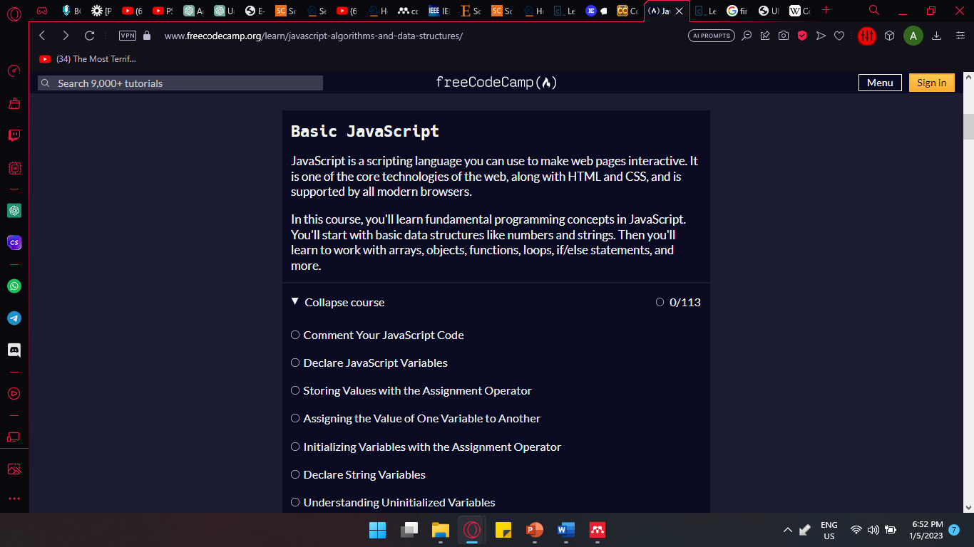

Figure 2. 4 FreeCodeCamp Basic JavaScript course content

### **2.2.3 Code Combat**

CodeCombat it a very “different” way of learning coding, unlike other websites who teaches coding in a very professional and traditional educationally way, CodeCombat do it in a more interesting and engaging way that will for sure catch children’s interest.

CodeCombat is an online multiplayer game that teaches players how to code. The game is designed to make learning to code fun and engaging, especially for beginners and childrens. In the game, players control a character and navigate through a variety of levels, each with its own challenges and puzzles. To progress through the game, players must write and execute code in the game's programming language, which includes JavaScript, Python, and Lua. For example the user must execute the code “hero.moveRight();” to make the Character to move Right as shown in Figure 2.5.

CodeCombat's JavaScript course is designed to teach players the basics of JavaScript programming in a fun and interactive way. The course is divided into levels that gradually increase in difficulty as players progress through the game. Each level introduces new concepts and challenges, such as variables, functions, loops, and arrays.

One of the unique features of CodeCombat is its game-based approach to learning. Players are motivated to complete levels and progress through the game by earning experience points and unlocking new characters and items. The game also includes a leaderboard where players can compare their progress with others and compete for the top spot.

The user interface of CodeCombat is intuitive and easy to use. Players write and execute their code in a separate panel, while the game is displayed in a separate panel. The game also includes helpful features such as code highlighting and error messages to assist players as they write and debug their code.

Overall, CodeCombat’s JavaScript course is an effective and enjoyable way to learn JavaScript programming. The game-based approach makes learning fun and engaging, while the gradual increase in difficulty and introduction of new concepts ensures that players build a solid foundation in JavaScript programming.

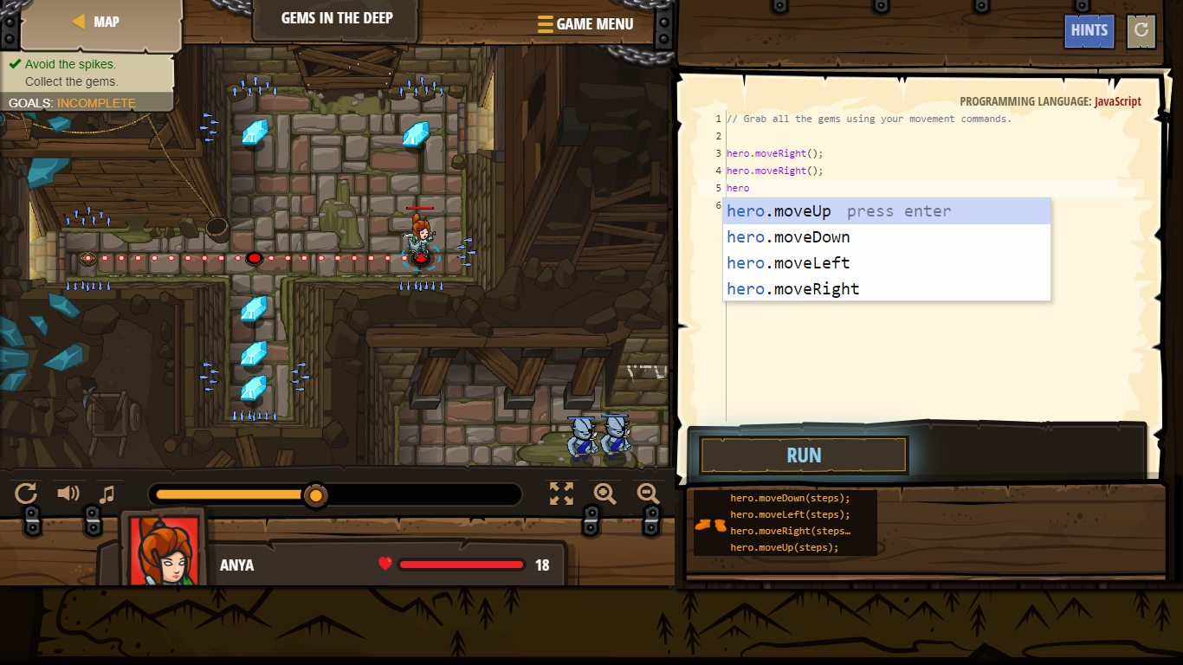

Figure 2. 5 CodeCombat gameplay

# **CHAPTER 3**

**METHODOLOGY**

## **3.1 Introduction**

A project management framework provides a comprehensive and well-defined approach to software development. It serves as a methodology for structuring, planning, and controlling the process of developing a system. There are various software development methodologies available, including waterfall development, agile development, rapid application development, spiral development, and many more. Each methodology has its unique set of advantages and disadvantages, making it essential to choose the appropriate methodology based on the project's requirements and constraints.

After careful consideration of various factors such as team structure, expenses, project requirements, goals, and budget, the Agile methodology was selected to develop the JavaScript learning website. This approach is well-suited for website development and can effectively meet the specific requirements of the project within the given timeframe of two semesters.

One of the main advantages of Agile methodology is its focus on user needs, which helps reduce the risk of defects and ensures that the requirements and functionalities are implemented correctly. The Agile methodology comprises five stages, namely requirements, design, development, testing, and deployment, as shown in Figure 3.1 which are cycled continuously to adapt to user feedback and ensure their satisfaction.

Through Agile development, users can validate the outcome and ensure that it meets their needs. This approach also enables the team to be flexible and make changes to the project as needed, without causing. This flexibility is crucial in software development, as it allows the team to respond quickly to changing requirements or feedback from stakeholders.

In conclusion, the Agile methodology was selected for the development of the JavaScript learning website, given its ability to meet the specific project requirements within the given timeframe while focusing on user needs and reducing the risk of defects. By following a structured Agile approach, the team can ensure that the website is developed efficiently and meets the requirements of stakeholder.

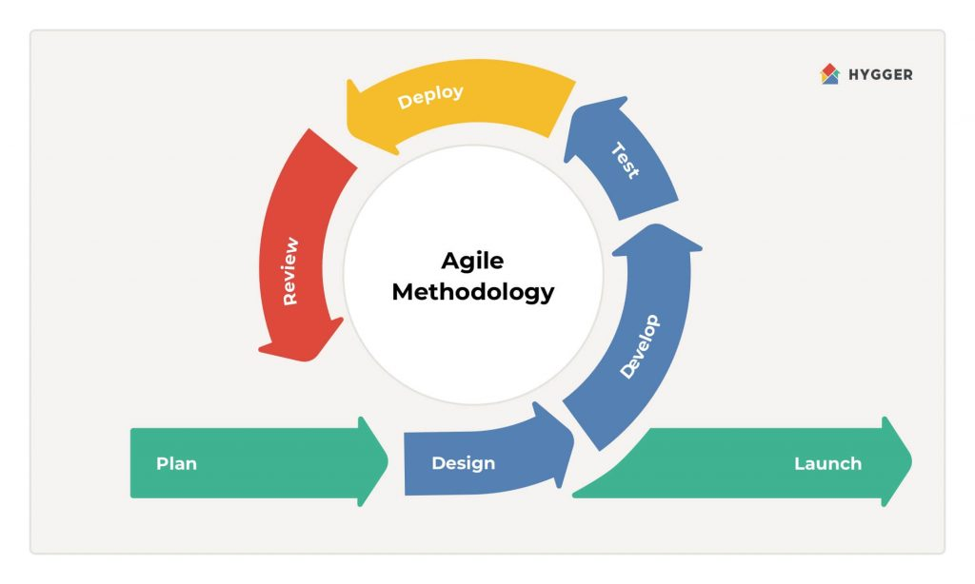

Figure 3. 1 Agile methodology cycle

### **3.2.1 Requirement phase**

The requirements phase is the first and most crucial stage in the Agile development process. It involves gathering and analysing the requirements of the proposed system, which forms the foundation of the entire project. To identify the problems with the current existing application, a thorough literature review was conducted. Based on the problems identified, the requirements for the proposed system were defined.

For example, during the analysis, it was found that most JavaScript learning materials provided by similar websites were in English, while learning materials in Bahasa Melayu were relatively few. Therefore, one of the key requirements for the proposed system was to offer the website in Bahasa Melayu, making it more accessible and inclusive for users who prefer to learn in their native language.

In addition to language support, there were many other requirements that needed to be identified and categorized into functional and non-functional requirements. Functional requirements describe the specific actions and tasks that the system must perform and the functions that it must offer, while non-functional requirements describe the overall properties and characteristics of the system.

Overall, the requirements phase plays a vital role in ensuring the success of the "learning JavaScript" website project by establishing a clear understanding of user needs and expectations and guiding the development team towards building a system that meets those requirements. Further details in requirements is provided in chapter 3.3 project requirements.

### **3.2.2 Design Phase**

During the design phase of the "learning JavaScript" website project, the requirements gathered in the previous phase were utilized to create a detailed design for the system. Wireframes and mockups were created to visualize the website's layout and functionality, ensuring that the website met users' needs and expectations and had easy navigation.

Once a clear understanding of the website's layout and structure was obtained, the user interface was designed with a focus on user-friendly and optimal user experience principles. User-cantered design principles were employed, and usability testing was conducted to ensure the website's interface was intuitive and easy to navigate.

In addition to the user interface, the website's architecture and data structures were also designed. This involved determining the website's build and structure, including the selection of the technology stack, programming languages, and data storage methods. Security and privacy concerns, such as data encryption and access controls, were considered to ensure user safety and security.

Overall, the design phase played a critical role in ensuring the "learning JavaScript" website was well-designed and met user needs. Detailed wireframes and mockups were created, a user-friendly interface was designed, and the website's architecture and data structures were carefully considered, resulting in a high-quality website that was both functional and visually appealing.

### **3.2.3 Development Phase**

During the development phase of the "learning JavaScript" website project, the website was built and coded based on the requirements and design specifications. An iterative approach was employed, breaking down the work into smaller tasks or sprints that could be completed and tested quickly.

The development of the database to store user progress and coding exercises was one of the initial tasks undertaken. A widely-used database management system was utilized, and a schema was designed to enable efficient storage and retrieval of user data.

Subsequently, the focus shifted to constructing the user interface and interactive features. A front-end web development framework and programming languages such as HTML, CSS, and JavaScript were utilized to create a user-friendly interface that facilitated easy website navigation and interaction with various features.

As part of the development phase, integration of any necessary third-party APIs or tools to enhance website functionality took place. For instance, a code editor and an online compiler were integrated, allowing users to test their code directly on the website.

Throughout the development phase, regular testing of the website occurred, and necessary changes were implemented to ensure adherence to requirements and design specifications. This iterative approach enabled prompt identification and resolution of any issues, resulting in a high-quality website that met user needs.

Overall, the development phase played a crucial role in building and coding the "learning JavaScript" website. The iterative approach, robust database development, creation of the user interface and interactive features, and integration of third-party APIs contributed to the creation of a high-quality website that provided an optimal learning experience for users.

### **3.2.4 Testing Phase**

During the testing phase, the website was thoroughly evaluated to ensure compliance with both functional and non-functional requirements while identifying and resolving any bugs or errors. For the "learning JavaScript" website project, user testing was conducted to gather feedback on the website's usability and effectiveness. This allowed for improvements to be made based on user input, ensuring a more user-friendly experience.

Overall, the testing phase played a crucial role in validating the website's functionality, identifying and rectifying any issues, and ensuring that the "learning JavaScript" website met both user expectations and technical requirements.

### **3.2.5 Deploy Phase**

In the Deploy phase, the web hosting service will be selected, and the website will be deployed to a live server. The server settings, including security measures and performance optimization, will be configured to ensure the website's secure operation and smooth performance.

After the website is live, comprehensive testing will be conducted to ensure that all functionalities are functioning correctly. Performance monitoring and usage data analysis will be performed to identify any issues or areas that require improvement.

User feedback will be collected and used to implement necessary updates and improvements to the website. This may involve adding new features, enhancing existing ones, and resolving any identified bugs or errors. Ongoing maintenance and support will be provided to ensure the continuous smooth operation of the website and to meet the evolving needs of its users.

## **3.3 Project requirements**

Functional Requirements:

1. The website should provide interactive coding challenges and exercises for users to practice coding in JavaScript.
2. The website should include comprehensive documentation and tutorials to help users learn the basic syntax and concepts of JavaScript.
3. The website should allow users to track their progress and save their work as they complete coding challenges.
4. The website should offer multiple levels of difficulty for coding challenges, allowing users to progress from beginner to advanced levels.
5. The website should offer real-world coding examples and scenarios to help users apply their knowledge of JavaScript to practical situations.
6. The website should offer quizzes and assessments to test users' understanding of JavaScript concepts and syntax.

Non-Functional Requirements:

1. The website should be responsive and accessible from multiple devices such as desktops, laptops, tablets, and smartphones.
2. The website should load quickly and efficiently, with minimal wait times and no significant lag.
3. The website should be secure and protect user data and information from unauthorized access or theft.
4. The website should be scalable and able to handle a high volume of users and traffic without crashing or slowing down.
5. The website should be easy to navigate and use, with an intuitive user interface that requires minimal training or assistance.
6. The website should be designed with a visually appealing and engaging layout to encourage user engagement and motivation.
7. The website should provide clear and concise error messages to users to help them identify and correct mistakes in their code.

## **3.4 Proposed Design**

1. Homepage: The homepage will provide an overview of the website's features and resources. It will include a visually appealing layout with clear navigation options to different sections of the website. The homepage will also showcase featured coding challenges, tutorials, and testimonials from satisfied users.
2. Coding Challenges and Exercises: The website will offer interactive coding challenges and exercises for users to practice coding in JavaScript. Each challenge will have a specific objective and difficulty level. Users will be able to access a variety of coding exercises categorized by topics such as variables, functions, arrays, and more. The coding challenges will provide an online code editor where users can write and test their code, and the results will be displayed immediately.
3. Documentation and Tutorials: Comprehensive documentation and tutorials will be provided to help users learn the basic syntax and concepts of JavaScript. The documentation will cover topics such as variables, data types, control flow, functions, and more. The tutorials will include step-by-step instructions, code examples, and explanations to help users understand and apply JavaScript concepts effectively.
4. User Progress Tracking: The website will allow users to track their progress as they complete coding challenges and exercises. Users will have personal accounts where they can save their work, view their completed challenges, and track their learning progress. Progress indicators and badges will be displayed to motivate users and provide a sense of accomplishment as they advance through different levels and topics.
5. Difficulty Levels: The coding challenges will be categorized into multiple levels of difficulty, ranging from beginner to advanced. Users can start with easier challenges and gradually progress to more complex ones as they gain proficiency in JavaScript. This progression system will provide a structured learning path and ensure that users are appropriately challenged at each stage of their learning journey.
6. Real-World Examples and Scenarios: The website will incorporate real-world coding examples and scenarios to help users apply their knowledge of JavaScript to practical situations. These examples will demonstrate how JavaScript is used in web development, interactive web applications, and other relevant contexts. Users will be able to explore and modify the code examples to deepen their understanding and see the results in real-time.
7. Quizzes and Assessments: The website will offer quizzes and assessments to test users' understanding of JavaScript concepts and syntax. These quizzes will be interactive and provide immediate feedback on the user's performance. Users can review their answers, identify areas of improvement, and retake quizzes to reinforce their learning.
8. Responsive Design: The website will be designed to be responsive and accessible from multiple devices, including desktops, laptops, tablets, and smartphones. The layout and content will adapt to different screen sizes and resolutions, providing an optimal viewing and interactive experience across devices.
9. Security and Privacy: To ensure the security and privacy of user data and information, appropriate measures will be implemented. This includes data encryption, secure user authentication, and adherence to privacy regulations. Users' personal information and progress data will be stored securely and treated with confidentiality.
10. Intuitive User Interface: The website will have an intuitive user interface that is easy to navigate and use. Clear and consistent navigation menus, buttons, and icons will guide users through different sections and features of the website. The user interface will be designed with user-centered principles, focusing on simplicity, clarity, and ease of use.
11. Visual Appeal: The website will be designed with a visually appealing and engaging layout to enhance user engagement and motivation. The use of appropriate colors, typography, and visuals will create a visually pleasing environment that encourages users to explore and learn. Visual elements will be used strategically to highlight important information, code examples, and user progress.
12. Error Handling and Feedback: Clear and concise error messages will be provided to users to help them identify and correct mistakes in their code. Feedback mechanisms, such as notifications and tooltips, will be implemented to guide users and provide assistance when needed. These error handling and feedback features will enhance the user learning experience and minimize frustration.

## **3.5 Data Design**

### **3.5.1 Context Diagram**

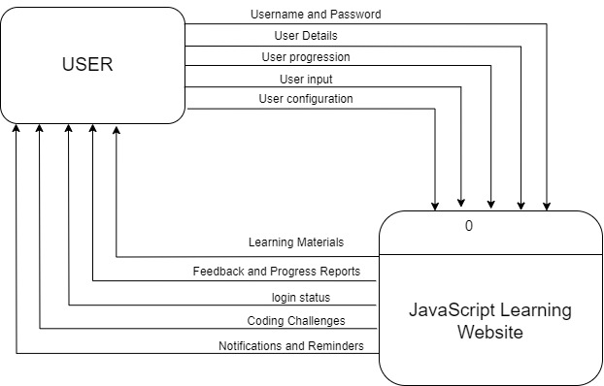

Figure 3.1 Context Diagram

### **3.5.2 User Case Diagram & Descriptions**

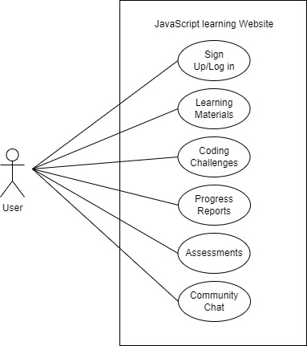

Figure 3.2 User Case Diagram

|  |  |
| --- | --- |
| **Use case name** | Sign Up/Log in |
| **Brief description** | This use case allows a user to create a new account or log in to an existing account on the "Learning JavaScript" website. |
| **Actor** | User |
| **Pre-condition** | * The user must have access to the website and have an internet connection. |
| **Basic flow** | * 1. The user accesses the website's sign-up/login page.   2. If the user already has an account, they select the login option and enter their login credentials.   3. If the user does not have an account, they select the sign-up option and provide the required information, such as name, email address, and password.   4. The system verifies the user's information and grants access to the website upon successful authentication. |
| **Exception flow** | If the user enters invalid login credentials or provides incomplete/invalid information during the sign-up process, the system displays an error message and prompts the user to correct the errors. |
| **Post condition** | The user is successfully logged in and gains access to the website's features. |
| **Constraints** |  |

|  |  |
| --- | --- |
| **Use case name** | Learning Materials |
| **Brief description** | This use case involves providing users with access to learning materials and tutorials related to JavaScript. |
| **Actor** | User |
| **Pre-condition** | * The user must be logged in to the website to access the entire content in this use case |
| **Basic flow** | 1. The user selects the learning materials option from the website's navigation menu. 2. The system displays a list of available learning materials, organized by topics or categories. 3. The user selects a specific learning material to access its content. 4. The system presents the learning material, which may include articles, videos, interactive tutorials, or documentation. |
| **Exception flow** | If there are no learning materials available or there is an error in retrieving the content, the system displays an appropriate error message to the user. |
| **Post condition** | The user can view and interact with the selected learning material. |
| **Constraints** |  |

|  |  |
| --- | --- |
| **Use case name** | Coding Challenges |
| **Brief description** | This use case enables users to practice their JavaScript coding skills through interactive coding challenges. |
| **Actor** | User |
| **Pre-condition** | * The user must be logged in to the website to access this use case fully. |
| **Basic flow** | 1. The user selects the coding challenges option from the website's navigation menu. 2. The system presents a list of available coding challenges. 3. The user selects a specific coding challenge to view its description and instructions. 4. The user writes their JavaScript code as a solution to the coding challenge. 5. The user submits their code for evaluation. 6. The system evaluates the code and provides feedback on its correctness. 7. The user can iterate and submit multiple attempts until they solve the coding challenge. |
| **Exception flow** | If there are no learning materials available or there is an error in retrieving the content, the system displays an appropriate error message to the user. |
| **Post condition** | The user can view and interact with the selected learning material. |
| **Constraints** |  |

|  |  |
| --- | --- |
| **Use case name** | Progress Reports |
| **Brief description** | This use case allows users to track and view their progress and performance on the "Learning JavaScript" website. |
| **Actor** | User |
| **Pre-condition** | * The user must be logged in to the website to access the entire content in this use case |
| **Basic flow** | 1. The user selects the progress reports option from the website's navigation menu. 2. The system generates and displays a progress report, summarizing the user's completed coding challenges, learning materials accessed, and overall performance. |
| **Exception flow** | If there is an error in generating the progress report or retrieving the user's data, the system displays an appropriate error message to the user. |
| **Post condition** | The user can view their progress and performance on the website. |
| **Constraints** |  |

|  |  |
| --- | --- |
| **Use case name** | Assessments |
| **Brief description** | This use case allows users to take assessments or quizzes to test their understanding of JavaScript concepts. |
| **Actor** | User |
| **Pre-condition** | * The user must be logged in to the website. |
| **Basic flow** | 1. The user selects the assessments option from the website's navigation menu. 2. The system presents a list of available assessments or quizzes. 3. The user selects a specific assessment to start the test. 4. The user answers the assessment questions related to JavaScript concepts. |
| **Exception flow** | If there is an error in submitting the assessment or evaluating the answers, the system displays an appropriate error message to the user. |
| **Post condition** | The user receives a score or feedback on their assessment and can review their answers. |
| **Constraints** |  |

|  |  |
| --- | --- |
| **Use case name** | Community Chat |
| **Brief description** | This use case allows users to engage in a community chat or forum to interact with other users and discuss JavaScript-related topics. |
| **Actor** | User |
| **Pre-condition** | * The user must be logged in to the website. |
| **Basic flow** | 1. The user selects the community chat option from the website's navigation menu. 2. The system presents the community chat interface, displaying ongoing discussions and topics. 3. The user can participate in existing discussions by posting messages or create new discussion threads. 4. The user can view and respond to messages posted by other users. |
| **Exception flow** | If there is an error in loading the community chat or posting messages, the system displays an appropriate error message to the user. |
| **Post condition** | The user can engage in discussions and interact with other users in the community chat. |
| **Constraints** |  |

### **3.5.3 Activity Diagram**

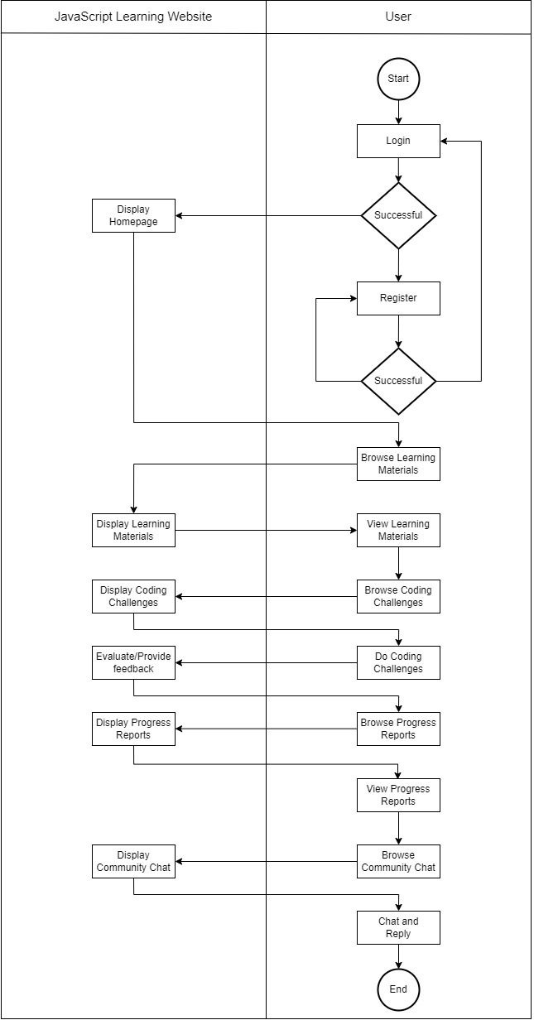

Figure 3. 3 Activity Diagram

### **3.5.4 Entity-Relationship Diagram (ERD)**

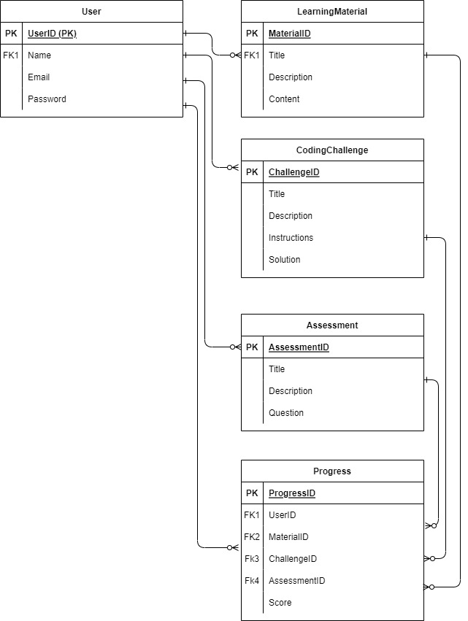

Figure 3. 4 Entity-Relationship Diagram

### **3.5.5 Database Dictionary**

Database Design and Data Model:

User:

UserID (Primary Key, auto-incremented integer): A unique identifier for each user.

Name (String): The name of the user.

Email (String): The email address of the user.

Password (String): The password of the user's account.

LearningMaterial:

MaterialID (Primary Key): A unique identifier for each learning material.

Title (String): The title of the learning material.

Description (String): A brief description of the learning material.

Content (String): The content or text of the learning material.

CodingChallenge:

ChallengeID (Primary Key): A unique identifier for each coding challenge.

Title (String): The title of the coding challenge.

Description (String): A brief description of the coding challenge.

Instructions (String): The instructions or guidelines for completing the coding challenge.

Assessment:

AssessmentID (Primary Key): A unique identifier for each assessment.

Title (String): The title of the assessment.

Description (String): A brief description of the assessment.

Progress:

UserID (Foreign Key referencing User.UserID): The identifier of the user associated with the progress.

MaterialID (Foreign Key referencing LearningMaterial.MaterialID): The identifier of the learning material associated with the progress.

ChallengeID (Foreign Key referencing CodingChallenge.ChallengeID): The identifier of the coding challenge associated with the progress.

AssessmentID (Foreign Key referencing Assessment.AssessmentID): The identifier of the assessment associated with the progress.

Score (Integer): The score or progress achieved by the user.

Relationship:

* User and LearningMaterial: One-to-Many relationship. One user can create multiple learning materials, but each learning material is associated with only one user.
* User and CodingChallenge: One-to-Many relationship. One user can create multiple coding challenges, but each coding challenge is associated with only one user.
* User and Assessment: One-to-Many relationship. One user can create multiple assessments, but each assessment is associated with only one user.
* User and Progress: One-to-Many relationship. One user can have multiple progress entries, but each progress entry is associated with only one user.
* LearningMaterial and Progress: One-to-Many relationship. One learning material can have multiple progress entries, but each progress entry is associated with only one learning material.
* CodingChallenge and Progress: One-to-Many relationship. One coding challenge can have multiple progress entries, but each progress entry is associated with only one coding challenge.
* Assessment and Progress: One-to-Many relationship. One assessment can have multiple progress entries, but each progress entry is associated with only one assessment.

## **3.6 Proof of Initial Concept**

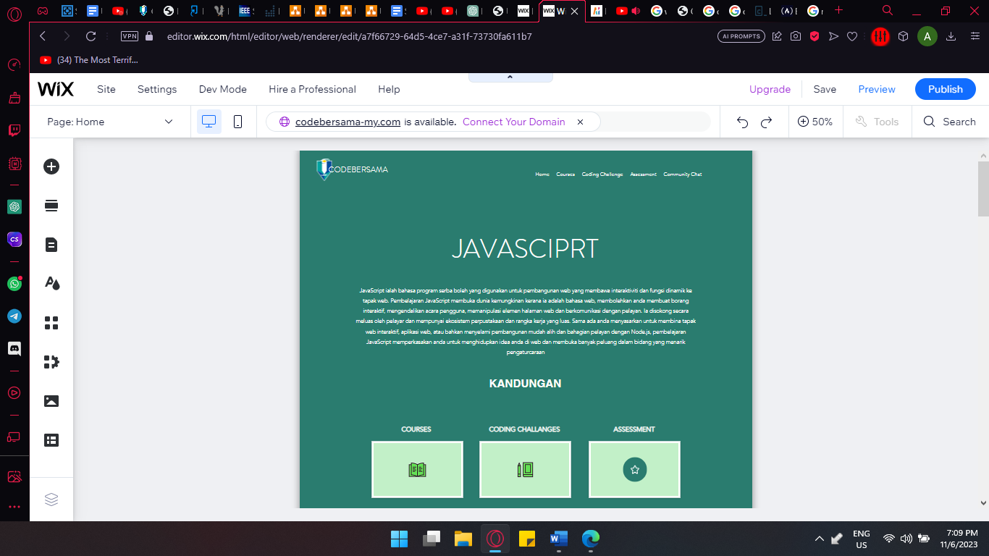

Figure 3.5 Home Page of prototype

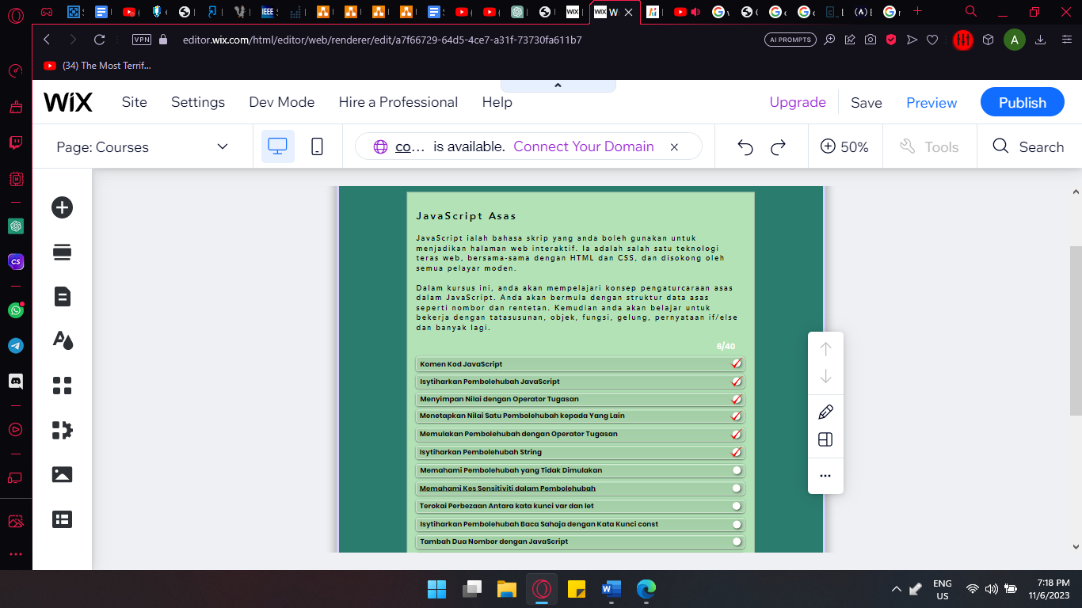

Figure 3.6 List of learning materials on prototype

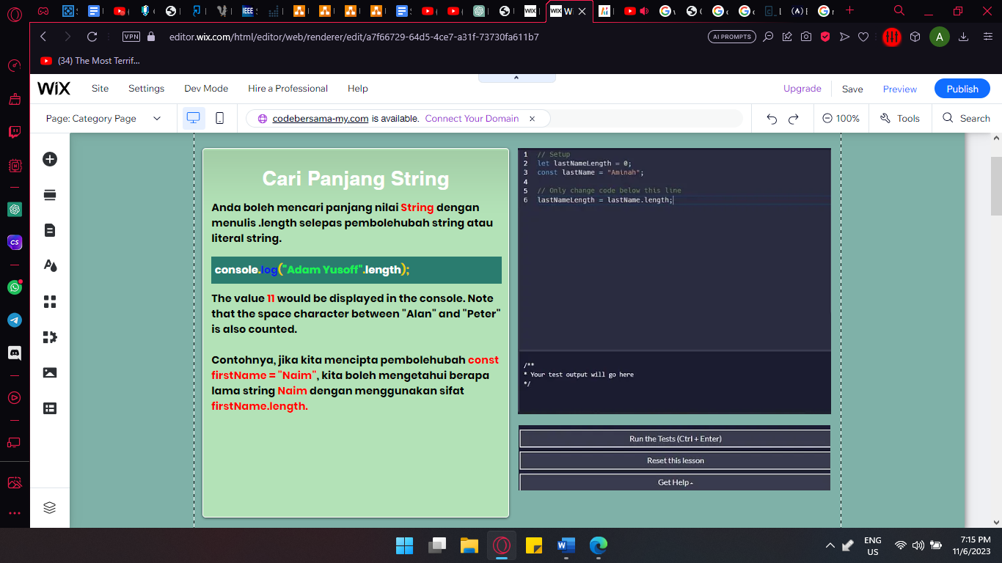

Figure 3.7 Course/ challenge/ Assessment prototype

## **3.7 Testing/Validation Plan**

### **3.7.1 Functionality Acceptance Test**

|  |  |  |  |
| --- | --- | --- | --- |
| No. | Functionality | Expected result | Result |
| 1. | Home page button | Able to take user to the home page | pass |
| 2. | Navigation button | Able to navigate the website through the navigation button | pass |
| 3. | Sign up button | Able to take user to registration page | pass |
| 4. | Register button | Able to take user’s information and make a account | pass |
| 5. | Login button | Able to login into account | pass |
| 6. | Code editor | Able to write and edit code in code editor area | pass |
| 7. | Code compiler | Able to run code and display output | pass |

### **3.7.2 User Acceptance Test**

|  |  |  |  |  |  |  |  |
| --- | --- | --- | --- | --- | --- | --- | --- |
| No. | Statements | Strongly Disagree | Disagree | Somewhat Disagree | Somewhat Agree | Agree | Strongly Agree |
| 1. | The website help you learn JavaScript. |  |  |  |  |  | x |
| 2. | The website is easily navigateable. |  |  |  |  |  | x |
| 3. | You are able to use the website easily |  |  |  |  |  | x |
| 4. | The functionality of the website work properly on your device. |  |  |  |  |  | x |
| 5. | This website runs smoothly in your device. |  |  |  |  |  | x |

## **3.8 Potential Use of Proposed Solution**

This project is meant to help Malaysian students overcome the challenges they face in learning JavaScript by providing a comprehensive and user-friendly platform, specifically tailored to the needs of Bahasa Melayu speakers. One potential use of the proposed solution is to offer a website entirely in Bahasa Melayu, catering to those who are more comfortable learning in their native language.

By providing learning materials, tutorials, and instructions in Bahasa Melayu, the website aims to eliminate language barriers that often hinder non-English speakers from fully grasping coding concepts. This localization of content allows students to understand programming concepts more effectively and accelerates their learning progress.

The use of Bahasa Melayu also extends to interactive elements such as coding challenges, quizzes, and assessments. By presenting these components in Bahasa Melayu, students can navigate through the exercises and evaluate their understanding of JavaScript in a language they are more familiar with. This personalized approach fosters a deeper comprehension of coding principles and promotes a more engaging learning experience.

Additionally, the website can incorporate discussion forums, chat rooms, and community features that operate primarily in Bahasa Melayu. These platforms provide a space for students to connect with peers, ask questions, and engage in discussions about programming concepts—all in their preferred language. This creates a supportive learning environment where students feel more comfortable expressing themselves and seeking help from others.

By emphasizing the availability of Bahasa Melayu content throughout the website, the proposed solution ensures that Malaysian students who are more proficient in Bahasa Melayu can fully benefit from the learning resources and interact with the coding community. This inclusive approach acknowledges the importance of language preference in effective learning and aims to empower students by providing them with the opportunity to learn JavaScript in a language they are most comfortable with.

In conclusion, the potential use of the proposed solution is to offer a comprehensive learning platform entirely in Bahasa Melayu, catering to the needs of Malaysian students who prefer to learn coding in their native language. By breaking down language barriers and providing localized content, the website aims to create an inclusive and accessible learning environment, empowering students to develop their JavaScript skills and succeed in the digital landscape.

## **3.9 Gantt Chart**

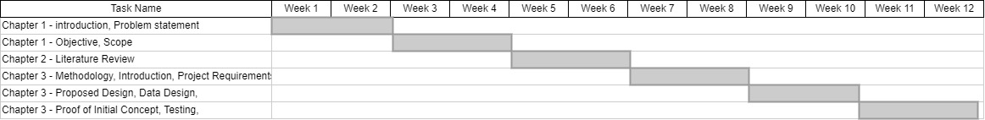

Figure 3.8 Gantt Chart

# **CHAPTER 4**

## **Overview**

This section will cover the findings derived from the project and subsequent discussion. Chapter 4.2 outlines the procedural steps taken in the implementation of the web application project. In Chapter 4.3, the testing process of the website with users is discussed, where user feedback is documented in in Table ##. Moving forward, Chapter 4.4 provides a concise overview of the results obtained from the application, encompassing the iser-utilized design and layout. Additionally, Chapter 4.5 outlines both the advantage and disadvantages of the web application. Finally, Chapter 4.6 serves as a conclusion, summarizing the entirety of the chapter content.

## **Implementation**

This Chapter explained about the steps in development and implementing various features of the web application. Each process involved is described briefly in this section. In general, this web application is using CodeMirror to implement a text editor in JavaScript for the browser and uses Babel Library to provide user with a coding environment to allow user to test and implement the learning materials provided alongside it.

CodeMirror stands out as a versatile browser-based text editor crafted in JavaScript. Tailored specially for code editing, it incorporates various language made and addons that enchases editing capabilities. This tool provides robust programming API and a CSS theming system that allow for seamless customization to align with the unique requirement of the web application of this project.

CodeMirror 5 can be obtained by going to their website [codemirror.net](https://codemirror.net/5/) and download their latest version.

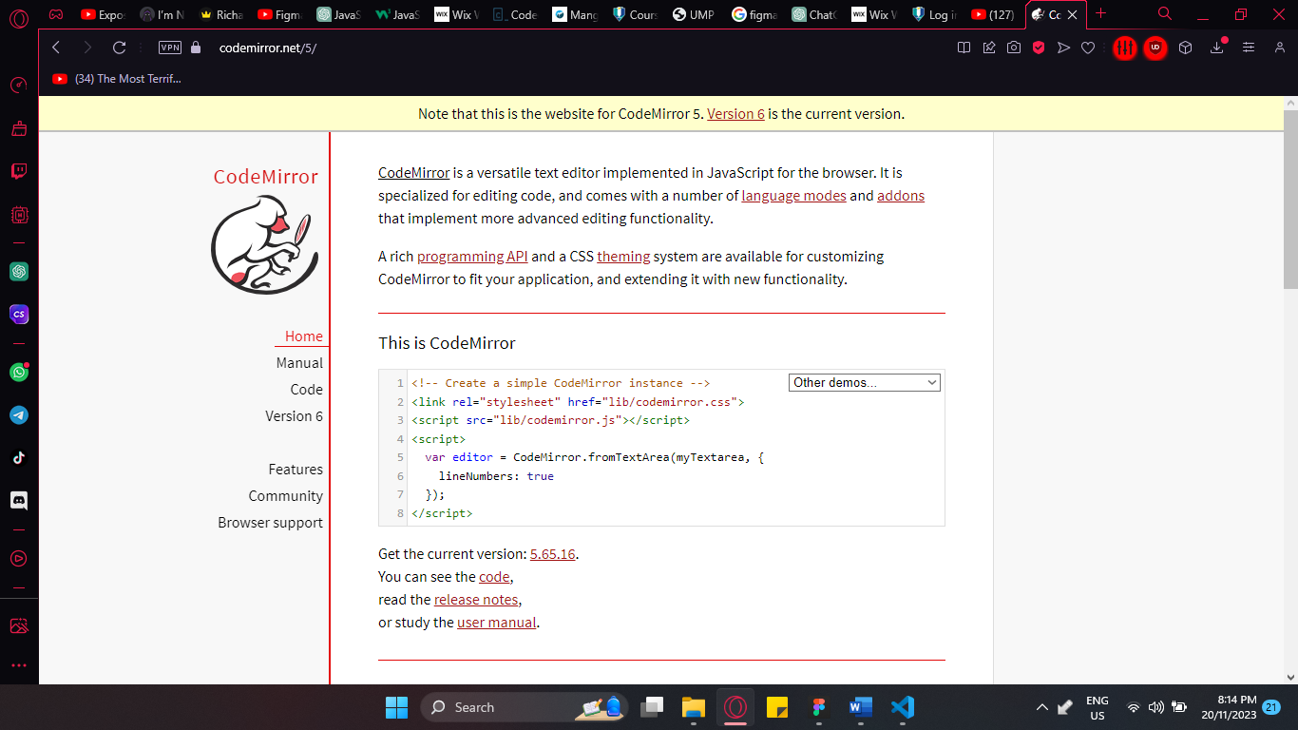

Figure 4.1 CodeMirror website.

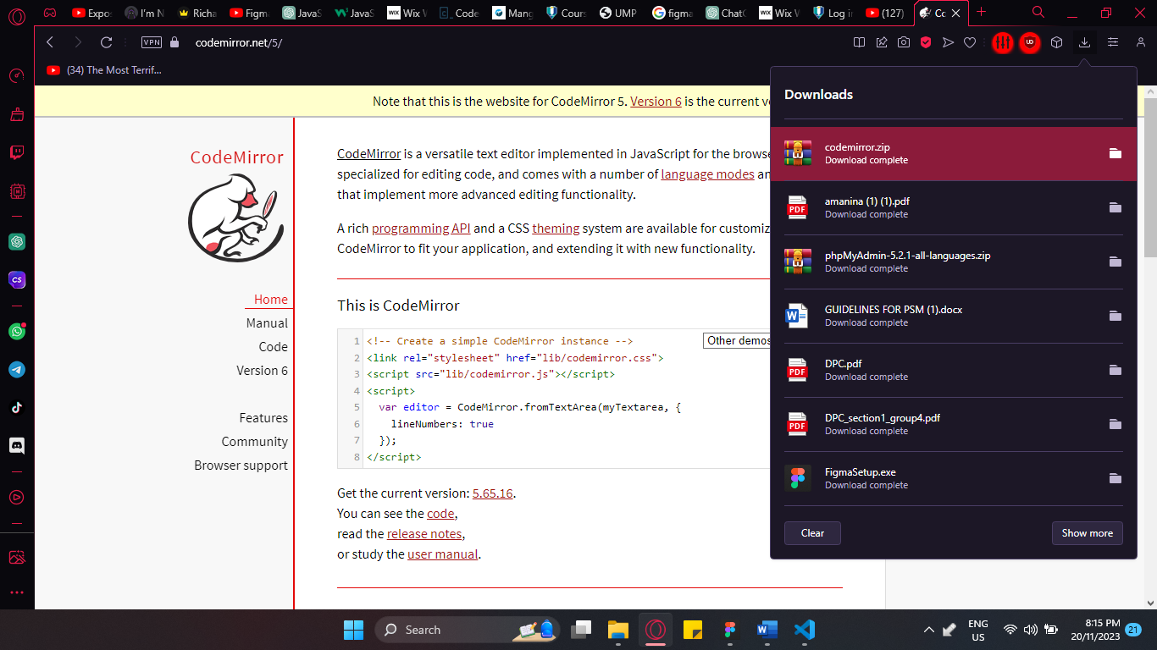

Figure 4.2 download the codemirror.zip file.

Include the .css and .js files inside into the web application html code. And customise the code editor area as pleased such as changing the theme, line numbers, plugins and addons and can be further manipulated using css.

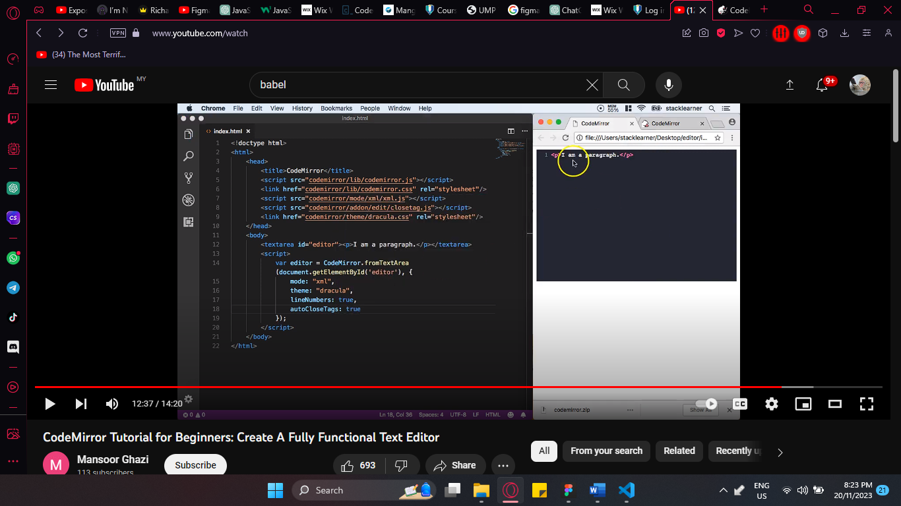

Figure 4.3 include the necessary files into the html code.

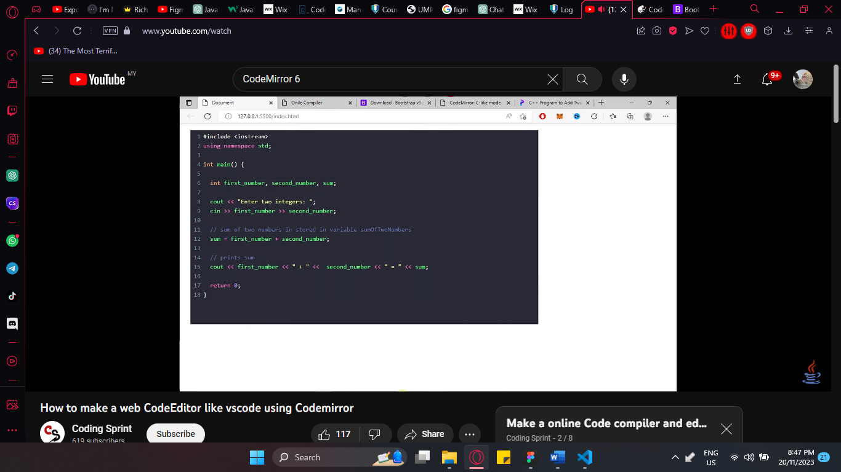

Figure 4.4 example of the code editor area.

Than in order to run or compile the code imputed in the code editor area, we can create a JavaScript function to run the code and display the output.

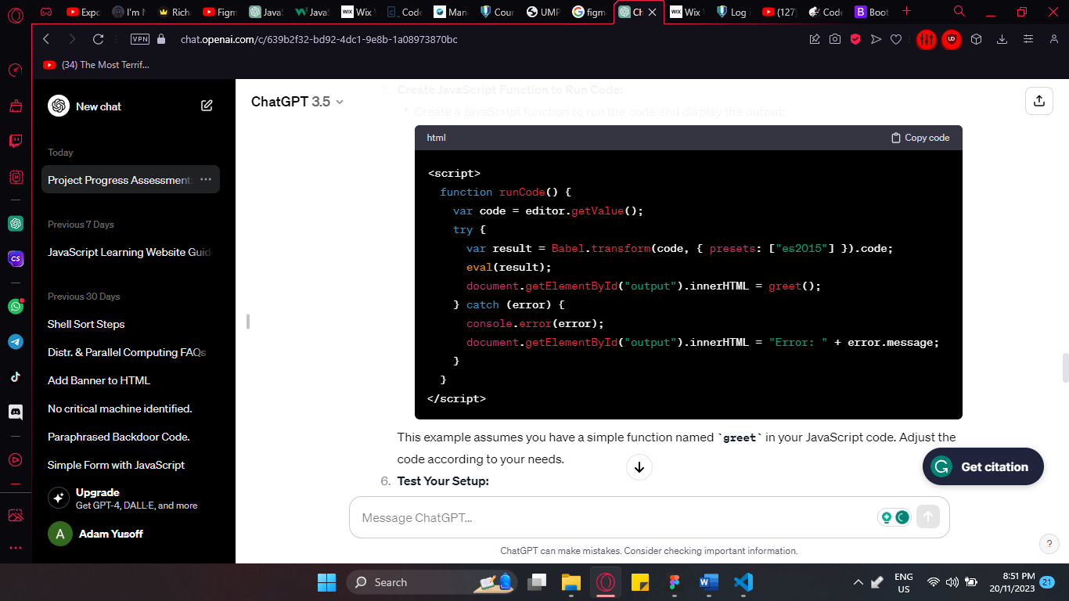

Figure 4.5 Run function.

## **Result**

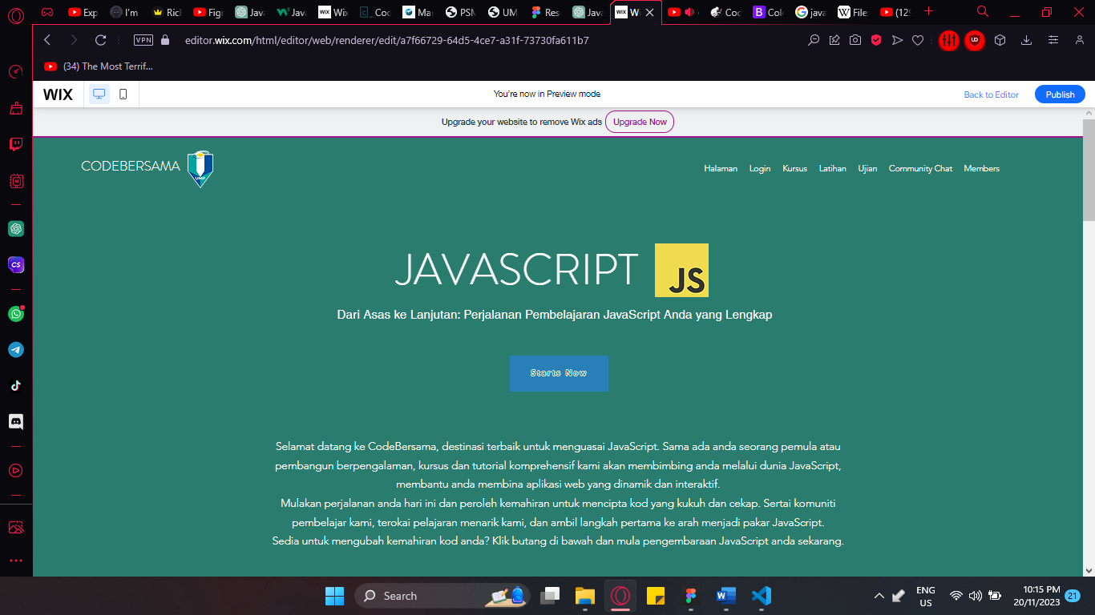

Figure 4.6 homepage

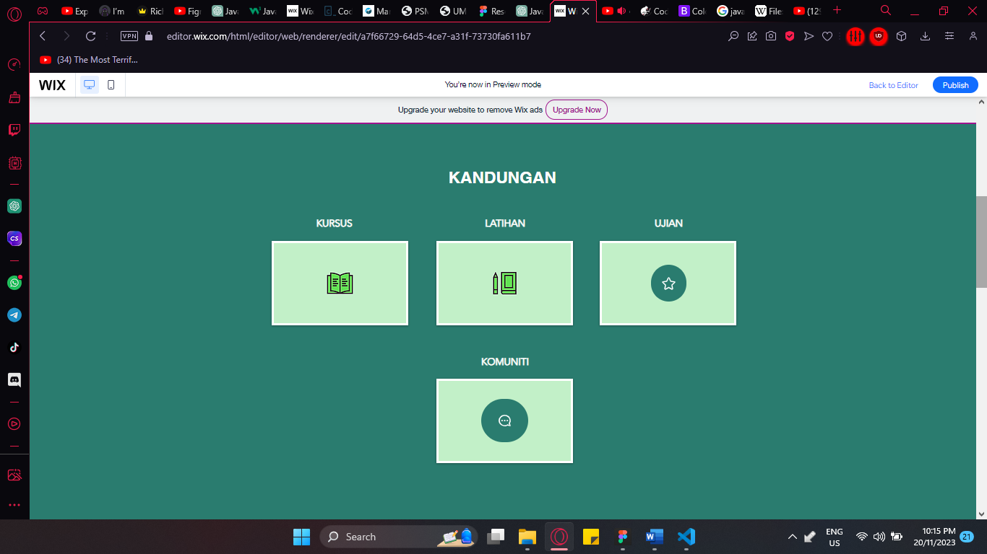

Figure 4.7 kandungan

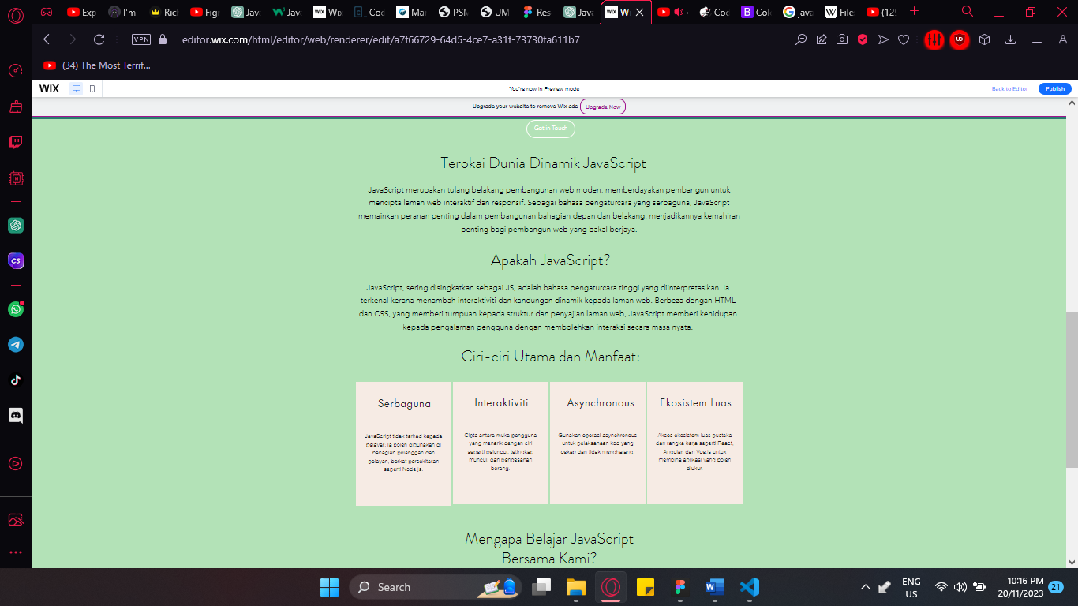

Figure 4.8 CodeBersama info

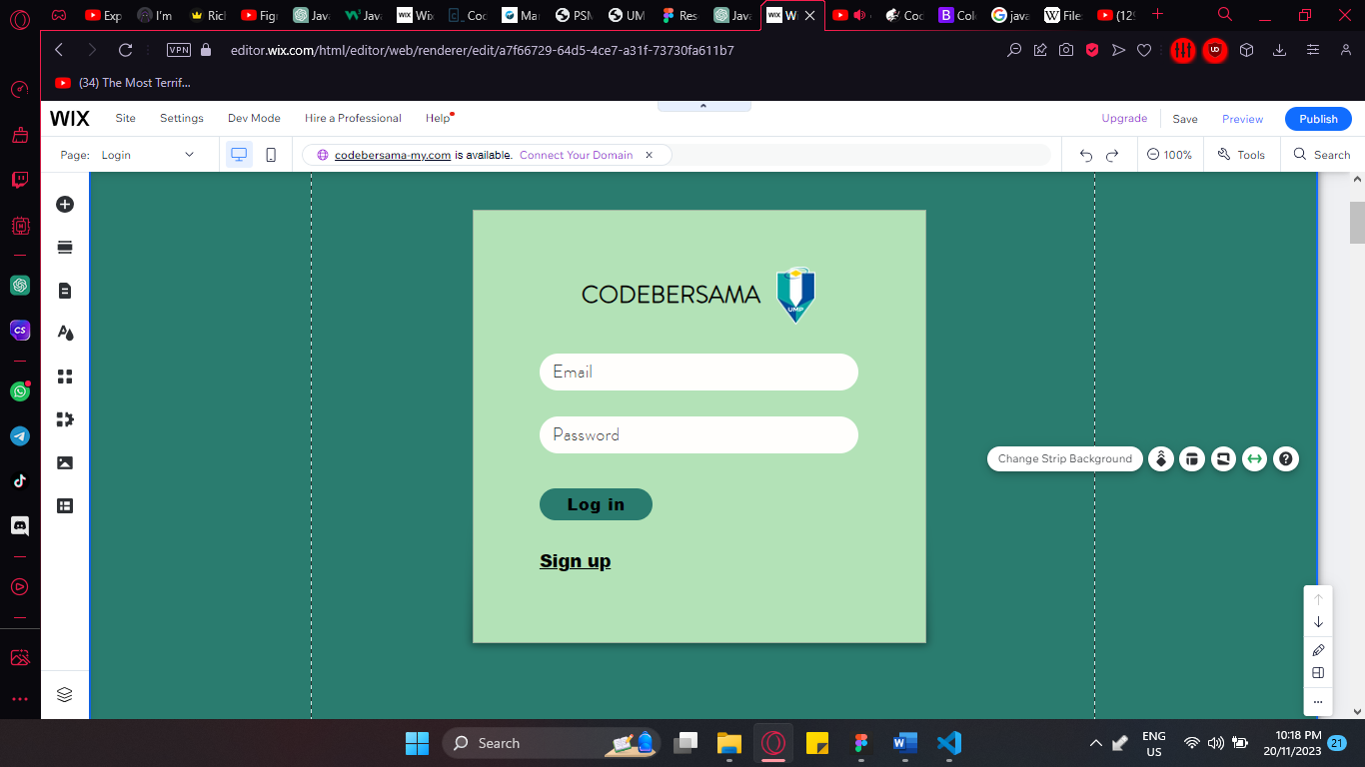

Figure 4.9 Login

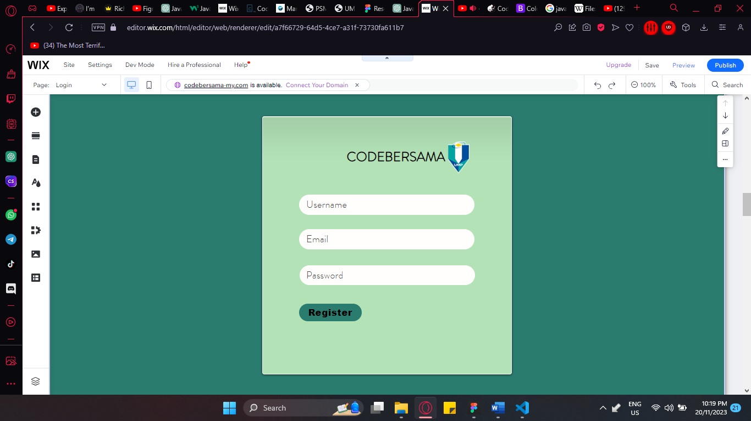

Figure 4.10 registration

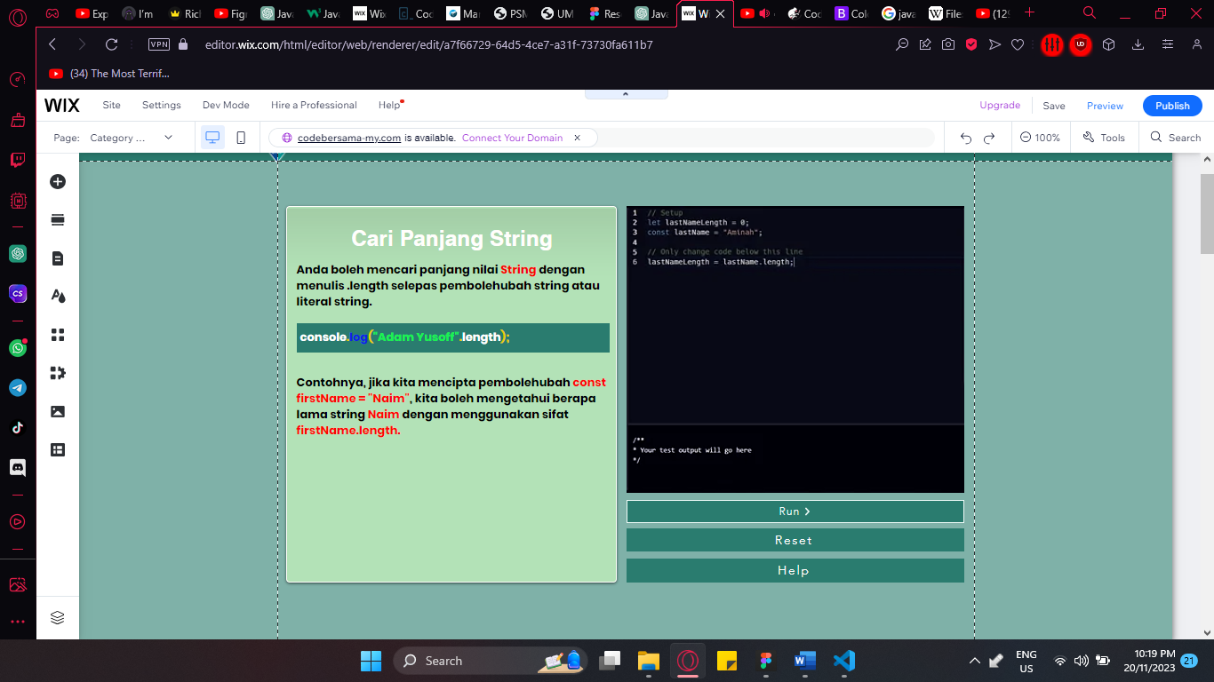

Figure 4.11 content and coding environment



Figure 4.12 content.

**REFERENCES**

Downes, P. K. (2007, May 26). *Creating a practice website*. Nature News. https://www.nature.com/articles/bdj.2007.424

Elsevier. (2010, June 13). *Agile software development methodologies and practices*. Advances in Computers. https://www.sciencedirect.com/science/article/abs/pii/S0065245810800014

Gemino, A., & Parker, D. (2009, January 1). *Use case diagrams in support of use case modeling: Deriving understanding from the picture*. Journal of Database Management (JDM). https://www.igi-global.com/article/use-case-diagrams-support-use/3398

Laoyan, S. (2022, October 15). *What is agile methodology? (a beginner’s guide) [2023] • asana*. Asana. https://asana.com/resources/agile-methodology

Li, Q., & Chen, Y.-L. (1970a, January 1). *Data Flow Diagram*. SpringerLink. https://link.springer.com/chapter/10.1007/978-3-540-89556-5_4

Li, Q., & Chen, Y.-L. (1970b, January 1). *Entity-relationship diagram*. SpringerLink. https://link.springer.com/chapter/10.1007/978-3-540-89556-5_6

Lowe, D. (2003, February 6). *Web system requirements: An overview - requirements engineering*. SpringerLink. https://link.springer.com/article/10.1007/s00766-002-0153-x

Moloto, M., Harmse, A., & Zuva, T. (1970, January 1). *Impact of agile methodology use on project success in organizations - A systematic literature review*. SpringerLink. https://link.springer.com/chapter/10.1007/978-3-030-63322-6_21

Sharma, R., Kumar, S. R., & Gupta, K. (n.d.). Strategies for Web Application Development Methodologies. https://ieeexplore.ieee.org/stamp/stamp.jsp?tp=&arnumber=7813710

Shen, W., & Liu, S. (1970, January 1). *Formalization, testing and execution of a use case diagram*. SpringerLink. https://link.springer.com/chapter/10.1007/978-3-540-39893-6_6

Study of effect of Agile Software Development Methodology ... - IEEE xplore. (n.d.). https://ieeexplore.ieee.org/document/9532842/